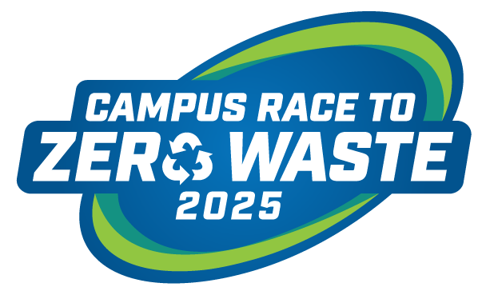

Contact: Insert Campus Communications Contact Here

Insert Campus Name Here Competes in 2025 Campus Race to Zero Waste Competition

[Insert location, insert date] – [Your campus name here] joined more than 1.4 million college students and staff across the country in a competition to reduce the campus waste footprint. Collectively, these campuses donated, composted and recycled more than 19.4 million pounds of waste. These waste minimization efforts prevented the release of 20,668 metric tons equivalent of carbon dioxide into the atmosphere, equal to avoiding the annual emissions from 4,351 cars.
[Insert quote from campus lead]
“The 2025 campus participants are leading the way to foster a culture of environmental awareness and sustainability in their communities,” says Stacy Wheeler, president and co-founder of the competition. “Campus innovations and systemic changes to address campus waste diversion and recycling are inspiring.”
[Insert Your Campus 2025 Results]

Suggestions to Highlight
- Ranking in Food Organics, Diversion, and Per Capita categories, and other categories (can be found on the 2025 Scoreboard webpage)
- Campus’s total pounds recycled, donated, or composted (reference your weekly reports)
- Campus’s waste minimization strategies
- Campus’s education and awareness strategies.

Learn more about [Insert campus name here] waste minimization efforts at: [Insert link].
For more details about our categories and winners, please visit the 2025 Scoreboard.

About Campus Race to Zero Waste
Campus Race to Zero Waste – formerly known as RecycleMania – is the nation’s premier waste reduction and recycling competition among colleges and universities, managed and governed by RecycleMania, Inc. Campus Race to Zero Waste has been helping campuses minimize waste and improve their recycling efforts since its launch in 2001.
***

[Insert sustainability mission or goals of your campus]
###

