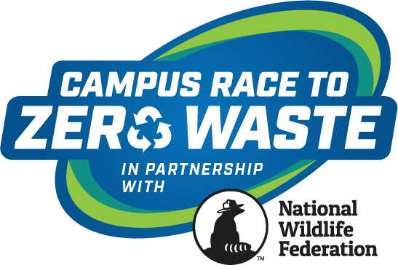

Contact: Insert Campus Communications Contact Here

Insert Campus Name Here Competes in National Wildlife Federation’s 2023 Campus Race to Zero Waste Competition

RESTON, Va. (May 3, 2023) – Your campus name here joined more than 3.4 million college students and staff across the country in a competition to reduce the campus waste footprint through minimization efforts by donating, composting and recycling more than 29.4 million pounds of waste. As a result, collectively, we have kept more than 200 million single-use plastic containers out of landfills and prevented the release of 29,108 metric tons equivalent of carbon dioxide into the atmosphere, equal to avoiding the annual emissions from 6,128 cars.
“The impact these colleges and universities have on reducing their waste footprint is tremendous and almost hard to comprehend. To prevent the release of more than 29,000 metric tons equivalent of carbon dioxide into the atmosphere and more than 200 million single-use plastics out of landfills is staggering and truly something to be proud of,” said Kristy Jones, director of higher education programs at National Wildlife Federation. “The collective efforts to minimize waste and reduce stress on natural resources is inspiring and creating a better world for wildlife and the environment.”
“Congratulations to all participating campuses,” says Stacy Wheeler, president and co-founder of the competition. “Annually the Campus Race to Zero Waste competition provides key tools and opportunities that inspire, empower and mobilize colleges and universities to improve their efforts to benchmark and promote their zero waste practices.”
Insert Your Campus 2023 Results

Suggestions to Highlight
- Ranking in Zero Waste, Food Organics, Diversion, and Per Capita categories, and other categories (can be found on the 2023 Scoreboard webpage)
- Campus’s total pounds recycled, donated or composted (reference your weekly reports)
- Campus’s total greenhouse gas emissions reductions (reference school page, can be found at: https://campusracetozerowaste.org/scoreboard/participating-schools/)
- Campus’s waste minimization strategies
- Campus’s education and awareness strategies.

Learn more about Insert campus name here waste minimization efforts at: Insert link.
For more details about our categories and winners, please visit the 2023 Scoreboard.

About Campus Race to Zero Waste
Campus Race to Zero Waste – formerly known as RecycleMania – is the nation’s premier waste reduction and recycling competition among colleges and universities, managed by National Wildlife Federation, and governed by RecycleMania, Inc. Campus Race to Zero Waste has been helping campuses minimize waste and improve their recycling efforts, since its launch in 2001.

***

Insert sustainability mission or goals of your campus
###

