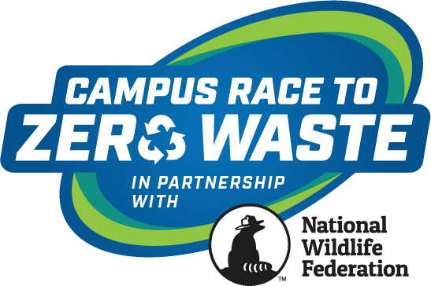

Contact: Insert Campus Communications Contact Here

Insert Campus Name Here Competes in National Wildlife Federation’s 2022 Campus Race to Zero Waste Competition

RESTON, Va. (May 2, 2022) – Your campus name here joined more than 3.6 million college students and staff across the country in a competition to reduce the campus waste footprint through minimization efforts by donating, composting and recycling more than 27.9 million pounds of waste. As a result, collectively, we have kept more than 200 million single-use plastic containers out of landfills and prevented the release of 30,288 metric tons equivalent of carbon dioxide into the atmosphere, equal to avoiding the annual emissions from 6,376 cars.
“Working alongside RecycleMania Inc. to engage and educate millions of students, staff and faculty in the U.S. has had an undeniable impact on the environment, wildlife and surrounding ecosystems. This competition demonstrates the monumental difference we can make if we come together to reduce our waste,” said Kim Martinez, vice president of education and engagement programs at the National Wildlife Federation. “We look forward to building this program’s decades long impact with our college and university partners.”
“Annually the Campus Race to Zero Waste competition provides key tools and opportunities that inspire, empower and mobilize colleges and universities to improve their efforts to reduce and eliminate waste,” says Stacy Wheeler, president and co-founder of the competition. “Congratulations to all participating campuses. Your efforts are significant and noteworthy. Your competition engagements on campus not only provide environmental and economic benefits, but are inherent of creating good global citizens of where we work, learn and live.”

Campus Race to Zero Waste 2022
A few key themes were clear during this year’s competition, campuses were eager to revive and relaunch waste reduction efforts that were halted or put on hold due to the pandemic. Many schools focused their efforts on local food security issues through support of food recovery programs and centered their education and awareness campaigns on waste disposal and safety.
Post-COVID pandemic, the Campus Race to Zero Waste program will be a vital tool to help campuses re-energize and re-educate their communities on good sustainable, waste reduction practices.
Insert Your Campus 2022 Results

Suggestions to Highlight
- Ranking in Zero Waste, Food Organics, Diversion, and Per Capita categories, and other categories (can be found on the 2022 Scoreboard webpage)
- Campus’s total pounds recycled, donated or composted (reference your weekly reports)
- Campus’s total greenhouse gas emissions reductions (reference school page, can be found at: https://recyclemania.org/scoreboard/participating-schools/)
- Campus’s waste minimization strategies
- Campus’s education and awareness strategies.

Learn more about Insert campus name here waste minimization efforts at: Insert link.
For more details about our categories and winners, please visit the 2022 Scoreboard.

About Campus Race to Zero Waste
Campus Race to Zero Waste – formerly known as RecycleMania – is the nation’s premier waste reduction and recycling competition among colleges and universities, managed by National Wildlife Federation, and governed by RecycleMania, Inc. Campus Race to Zero Waste has been helping campuses minimize waste and improve their recycling efforts, since its launch in 2001.

***

Insert sustainability mission or goals of your campus
###

