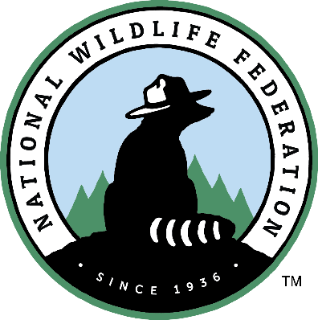
Contact: Insert Campus Communications Contact Here

Insert Campus Name Here Competes in National Wildlife Federation’s 2021 Campus Race to Zero Waste Competition

RESTON, Va. (May 4, 2021) – Your campus name here joined more than 200 campuses across the U.S. to participate in the 2021 Campus Race to Zero Waste competition, where they helped to reduce their waste footprint through waste minimization efforts, and donating composting, and recycling more than 25.8 million pounds of waste.
“Over the last two decades, more than 1,000 higher education campuses have joined our Campus Race to Zero Waste program. By reducing their waste, these campuses have decreased the amount of trash entering our waterways and the negative impacts this has on wildlife and ecosystems”, said Kim Martinez, vice president of education and engagement programs at the National Wildlife Federation. “Our organization is pleased to work alongside RecycleMania Inc. to engage and educate millions of students, staff, and faculty in the U.S. each year, and preserve this amazing program’s decades-long impacts on our environment.”
“Faculty, staff and students at participating CR2ZW colleges and universities, once again, have shown new innovations of combating the huge amounts of packaging, food and material products that are traditionally sent to nearby landfills or incinerators. CR2ZW participating campuses have either found new ways to prevent food or packaging waste in the first place or colleges have found successful ways to extend the usability of packaging or leftover food by giving these products second chances such as feeding the hungry and proving material for making biofuel or new consumer products”, says Stacy Wheeler, president and co-founder of the competition. “We are proud that the CR2ZW competition gives college participants an outlet to showcase better solutions to reducing campus waste and promoting recycling each year.”

Campus Race to Zero Waste 2021

Due to COVID-19 pandemic closings and increased online learning, many Campus Race to Zero Waste campuses were unable to reach the success levels accomplished in past years. However, campuses unable to track and report their waste were encouraged to host online education and engagement campaigns. These online campaigns helped schools stay connected with their faculty, staff and students and encourage the continued practices of good, safe waste reduction practices. Despite these difficult circumstances, this year’s tournament engaged 2.4 million students and more than 500,000 faculty and staff for a total of 2.9 million participants.
Participating colleges and universities donated, composted and recycled 25.8 million pounds of waste, and kept more than 230 million plastic containers out of the landfill. In eight weeks, participants prevented the release of 30,669 metric tons of carbon dioxide equivalent into the atmosphere, which is equal to avoiding the annual emissions from 6,463 cars.
Post-COVID pandemic, the Campus Race to Zero Waste program will be a vital tool to help campuses re-energize and re-educate their communities on good sustainable, waste reduction practices.
Insert Your Campus 2021 Results

Suggestions to Highlight
- Ranking in Diversion, Per Capita and Food Organics categories, and other categories (can be found on the 2021 Scoreboard webpage)
- Campus’s total pounds recycled, donated or composted (reference your weekly reports)
- Campus’s total greenhouse gas emissions reductions (reference school page, can be found at: https://recyclemania.org/scoreboard/participating-schools/)
- Campus’s waste minimization strategies
- Campus’s education and awareness strategies.

For more details about our categories and winners, please visit the 2021 Scoreboard.

About Campus Race to Zero Waste
Campus Race to Zero Waste – formerly known as RecycleMania – is the nation’s premier waste reduction and recycling competition among colleges and universities, managed by National Wildlife Federation, and governed by RecycleMania, Inc.
Campus Race to Zero Waste has been helping campuses minimize waste and improve their recycling efforts, since its launch in 2001. Today it is the nation’s premier waste reduction and recycling competition among colleges and universities, in partnership with the National Wildlife Federation.

Insert info about your campus sustainability website or other resources.

***

Insert sustainability mission or goals of your campus
###

